Bowie State University

Computer Science Department

Course: COSC 729 – Virtual reality and its applications

Lecturer: Dr. Sharad Sharma

Project Report

Modeling the Exceed Computer

By

Lubomír Říha

and

Victor Jeffrey Gittens

Due Date: 5th April, 2009

Table of Contents

What is the Xseed? 3

1. Description of the virtual environment 3

Fig 1. Model of the Xseed 3

FIG 2 Compute node of the Xseed 4

2. Acquiring the textures: 5

3. VRML 6

Fig 3 Simulation of the air flow 6

4. Hardware used for the project: 7

5. Software 7

5. Usefulness of the technology 8

6. Problems Encountered 8

7. Shortcomings 8

8. Future development 8

# What is the Xseed?

Xseed is a local name for the Bowie State University's Apple's G5 supercomputer. On March 9, 2005, Bowie State University, in cooperation with Apple Computer, Inc., built a $1 million supercomputer which the university named Xseed.

# 1. Description of the virtual environment

The objective in implementing the project was the creation of a virtual model of the Xseed computer of Bowie state University. This allows the user to interact with the computer. It was also the objective of the project to facilitate the user in understanding how the computer functions how it is built and how to operate it.

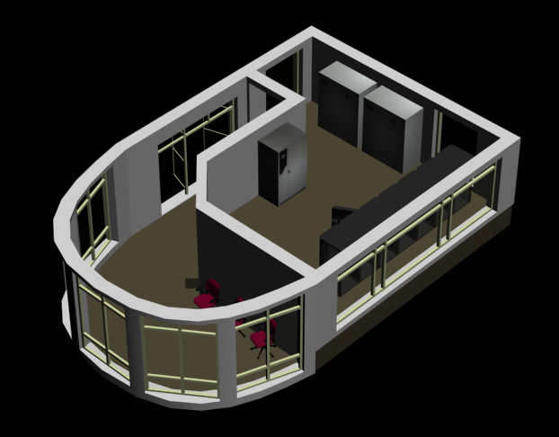

Fig 1. Model of the Xseed *room was created as a part of the project*

Xseed itself is built from 224 compute nodes and all of them are installed in 6six racks. The project sets about creating a detailed model of a compute node, head node, Xraid and all major parts of the Xseed. The user can open the rack from the back of the computer and see all the networking for both Myrinet and 1Gb Ethernet.

The user can also remove the compute node from the rack and examine the parts that make up the computer. The animation demonstrates how to change the processors, RAM sticks and HDD.

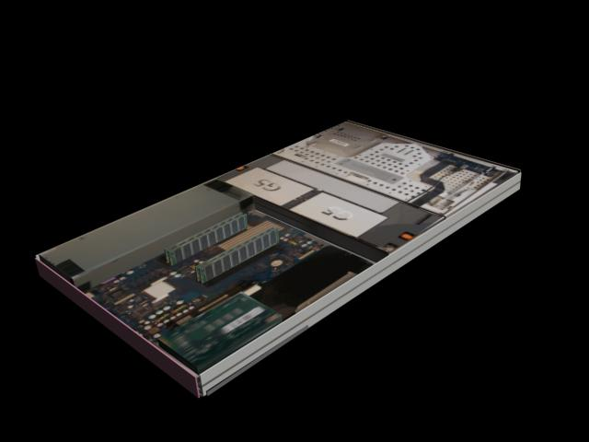

FIG 2 Compute node of the Xseed *when removed from the cabinet.*

The entire room which hosts the Xseed has been modeled and it is possible to do a walk through the computer room, examine and interact with all of the operational parts of the computer system.

Other Key parts of the Xseed which have been modeled include two cooling units and a power management unit which support the operation of the computer. The flow of the cold air which cools the computer system has also been modeled using particle systems. The user can turn on and off the cooling units and observe the temperature variation in the room. The animation can show by simulation what will happen if one cooling unit goes bad . Through interacting with the entire model he user can get a good picture it means to administer the supercomputer.

The main purpose if this application is to make Bowie State University supercomputer more accessible to the Information technology community

# 2. Acquiring the textures:

A major part of the project involved acquiring the various textures to be used in the development of the model of the Xseed. This took several photographic sessions of a disassembled node to be able to obtain the correct textures to be applied to the objects used in modeling the computer. He software used to edit the pictures included Photoshop and Gimp. These packages aided in producing the precise textures that were used in the model This was in keeping with the main goal of the project which was to create a realistic model of the Apple Xserve G5 compute and server node which is in fact the head node of the computer. The computer needed to be modeled in great detail because user will be able to open the rack and take the compute node out. The main parts can them be disassembled (main board, CPU, RAM stick, HDD, power supply, ...). All these parts were successfully modeled the APC rack in which the compute nodes are mounted. The path of the cool air from cooling units using the particle system was used to illustrate air flow. The cold air flows under the false floor to the front of the computers and then is heated inside the compute nodes. The rack contains three ventilators which have also been modeled. These conduct the heat away from the computers and from the rack. The model also illustrates the Ethernet and Myrinet network connections.

The Xseed has two different wire networks that can be clearly discerned from the model. This means that a large amount of cables emanate from the back of the computer cables in the back of the computer. These cables at the back of the computers will be created with ac combination of textures and objects. The problem here is that the model has a large number of polygons. All the textures are realistic materials of the Xseed taken by digital camera and put on the objects. A few textures of the computers were downloaded from Apple.

# 3. VRML

A touch sensor is being used to open used to open the racks, take the nodes out of the racks and disassemble the parts from the computer.

A Time Sensor is being used to simulate the airflow between cooling units and computer nodes.

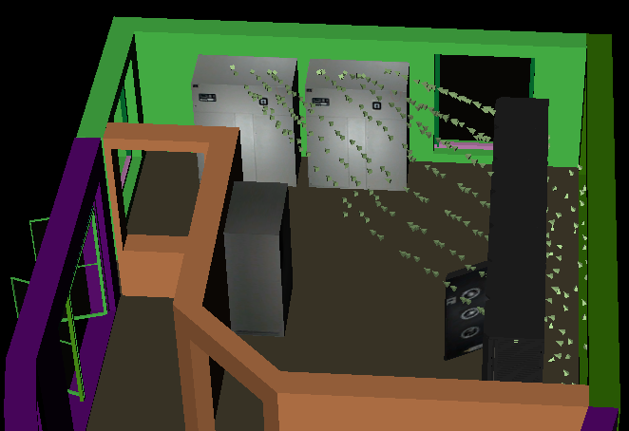

Fig 3 Simulation of the air flow *was the most challenging task because VRML cannot import particle systems*

Background - through the windows of the Xseed room the user can view part of the BSU campus. We will take a picture of this view and use it as a background.

Proximity Sensors - can be used to activate the screens of the computers in the room adjoining the Xseed Computer

Anchor – there are several viewpoints and an anchor is being used be used for switching between viewpoints in one VRML file.

Inline - the Xseed computer resides in one room, but there is another room right adjoining this one. Each room will be modeled separately and linked together using this node

Sound and AudioClip – The Xseed is a very noisy machine and there are a lots of beeping. This recorded noise is being used as background to the computer’s operation

When the computers nodes are in the racks only the front of the node is visible. As the nodes are taken out the detailed components of the node are displayed with animation

# 4. Hardware used for the project:

• Workstation with Intel (R) Core (TM)2 Quad CPU, Q66002.40GHz, 7.93GB RAM,465 GB hard disk.

• Apple G5-based cluster Super-Computer, X-Seed, that supports the department's educational and research activities. 224 dual 2.0GHz Xserve G5, each equipped with 2GB of RAM and an 80GB hard drive.

• 3D Scanner

# 5. Software

• 3D StudioMax 2009,

• VRMLpad 2.1,

• CosmoPlayer,

• Adobe PhotoShop,

• Gimp photo editor.

# 5. Usefulness of the technology

This application is useful for training students or faculty who are new to the computer. It gives a good picture of the entire machine and the environment in which it resides. It is good to expose first time users of the machine by the use of this model before they actually begin work on the machine itself. In this regard  
the virtual reality technology is most appropriate. We anticipate that this project will help Xseed to be more popular at BSU campus and at the other campuses in the area. Since the Xseed has now has a new web site, the model can be added to the site to illustrate how the computer works.

# 6. Problems Encountered

The problems encountered in the execution of the project primarily related to the level of detail and tedious work required in order to successfully develop a realistic image of the components of the computer. This was only accomplished with the investment of hours of re doing sections of the nodes and of the cabinets until some acceptable level of realism could be accomplished.

# 7. Shortcomings

The model can be considerably enhanced in the area of functionality. This can be enhanced with the production of a user manual for interacting with the model.

# 8. Future development

There is still considerable scope for future development work on the model especially in the area of functionality. Ideally it could be developed to the point where a simple program should be submitted to the model and it should execute it and return results to a monitor. This means that some attention will have to be paid to the functioning of the internal logic of the machine and the process stages of a program submitted to the machine for execution. Its interconnectivity to the web and the functionality that comes with web access to it can be considerably enhanced..